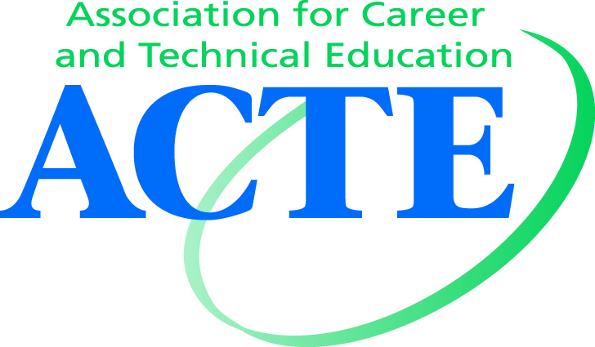
Awards Committee Member Position Description
Title: ACTE Awards Committee Member
Duration: One two-year term; eligible for up to two terms total
Work Location: Committee members conduct their work remotely by communicating via email and conference call. The Awards Committee will also meet in person at ACTE’s CareerTech VISION.

Impact of Work: Committee members are primarily responsible for facilitating the Region Member Awards scoring process and providing input into the national winner selection for the Member and Image Awards. Committee members will also assist in facilitating and/or providing input on other committee objectives. For more information on the committee mission and objectives, view the Committee Charter.

Commitment: While rewarding, serving on this committee requires a fairly substantial time commitment (estimated at 50+ hours through the year). See the committee workflow calendar for details.

Roles and Responsibilities:
As a Region representative on the National Committee:
- Read and respond to committee emails
- Review any materials provided in advance of calls/meetings
- Participate in scheduled conference calls and meetings, if available. If not available, provide input as necessary via email
- Maintain confidentiality regarding applicant information, scores and winners
- Familiarize oneself with the ACTE Awards and process; participate in Portal training
- Review and score national Member and Image Award applications

As Chair on your Region Awards Committee*:
- Assign judges to score Member Award applications for Region review
- Conduct interviews for Region finalists (if applicable; see your Region Awards guidelines)
- Review and score Region applications (Chair scores only counted in case of a tie)
- Review online scores throughout judging process; ensure that scores are tallied correctly and promote winners forward to national round by July 1 at the latest
- Ensure that Region winners and finalists receive recognition at your Region conference (if applicable). If your Region does not have a conference, ensure that winners and non-winners are notified.
*Region IV representatives do not serve in this role concurrently. See the Region IV Awards Manual.

Qualifications: All committee members must be members of ACTE national and be members of the respective Region/Division they are selected to represent. They must be able to meet the time commitment required to serve on the committee. Additional experience serving on an awards committee is strongly recommended.

Training/Orientation: All new committee members will be trained on the ACTE Awards Portal before they begin scoring national award applications and will also receive additional guiding materials.

Supervisor and Contact Information: All committee members report to the Chair. They will receive information throughout the year from the Chair and staff liaison. Contact for both can be found here.

Workflow Calendar
July:
- New committee members are welcomed to the committee and trained on the Awards Portal [1 hour]
- Committee members are assigned as national judges of the Member Awards (average 5 per category, 30-35 total) and begin scoring on the Portal. [20+ hours over three months]
August:
- Committee call to discuss scoring progress, new committee objectives, planning for October interviews, and other items [1 hour]
September:
- Provide input on interview questions via email [1-2 hours over 4 weeks]
- Complete review of written applications [recommended]
October:
- Participate in/review recorded interviews with national award winners via conference call [9+ hours]
- Submit final scores for all national candidates.
- Committee call to discuss VISION schedule, other business [1 hour]
- Review call minutes/review report to the Board
November:
- Committee meets in-person at VISION to discuss business, review SOP, elect (or re-elect) Chair and recognize outgoing members [1 hour]
- Committee members attend the ACTE Awards Banquet at VISION [2 hours]
- Review VISION meeting minutes
February:
- Remind states to upload winner applications to Awards Portal by March 1 deadline
- Recruit and assign judges for Region Awards Committee on Awards Portal
- Review report to the Board for March Board meeting
March:
- Facilitate scoring/candidate interviews for Region review, to be completed before Region conference or July 1.
April:
- Promote Image Awards May 1 application deadline
May:
- Score all Image Awards applications (average 5 per category, about 15 total) [5+ hours over 4 weeks]
- Committee call to review the winners per average scores at the end of the month; officially recommend winners to the Board of Directors [1 hour]
June:
- Committee reviews call minutes & committee report to the Board (for July Board meeting)
- Make sure all Region winners are promoted forward for national review by the July 1 deadline

